# Homework

## Software Development Models

### Guess which methodology corresponds to the diagram

Below you have 6 diagrams that represent 6 different development models, have a good look and fill your suggestions in the table below.

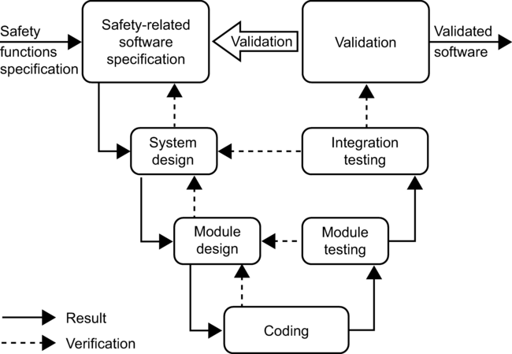

Figure 1

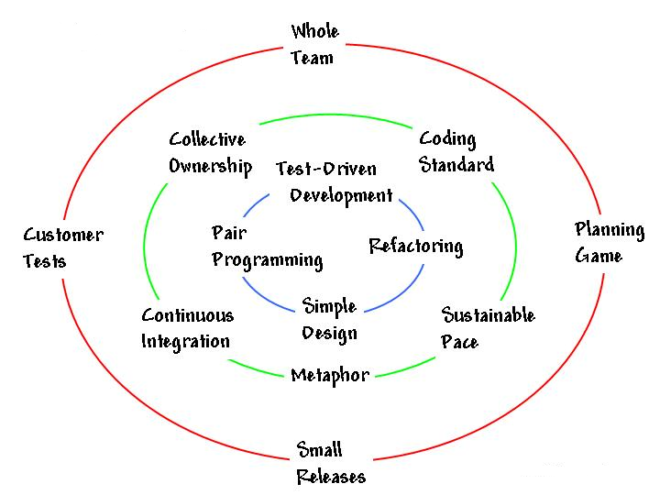

Figure 2

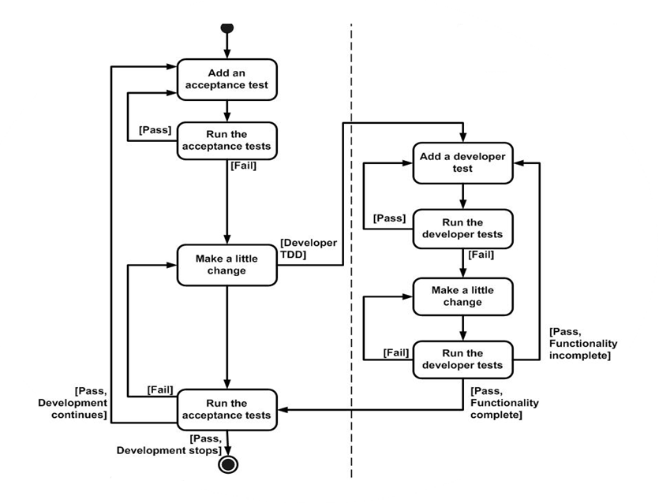

Figure 3

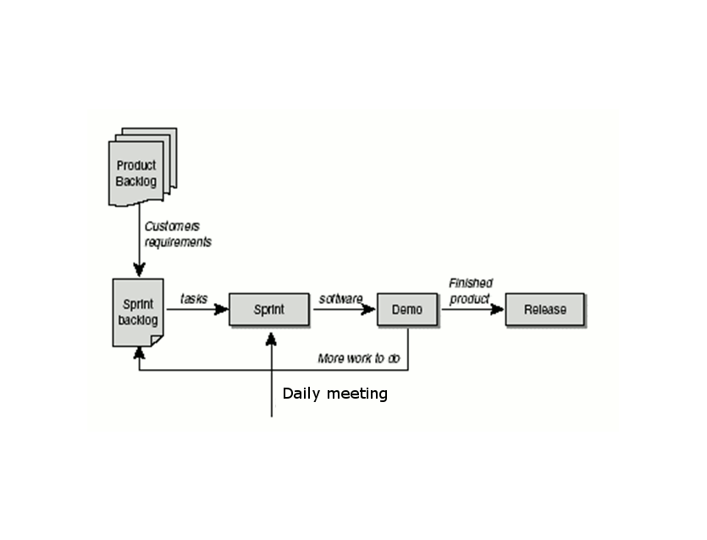

Figure 4

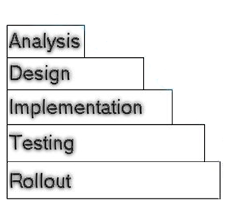

Figure 5

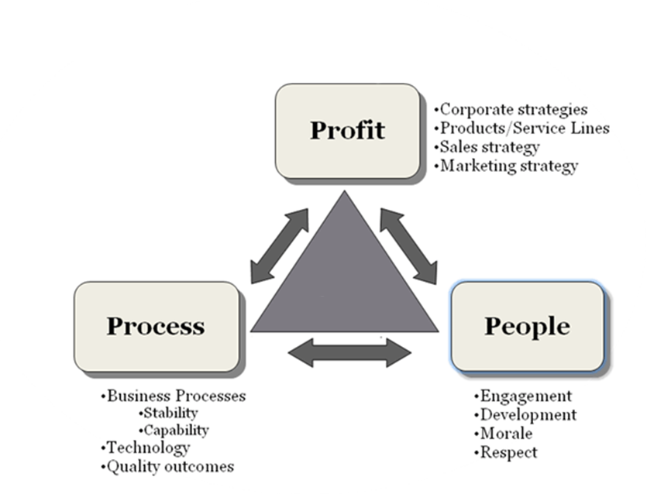

Figure 6

|  |  |
| --- | --- |
| Figure # | Methodology name |
| 111121. | V-Model |
| 2 2. | Extreme Programing |
| 3 3. | Test Driven Development |
| 4 4. | SCRUM |
| 5 5. | Waterfall |
| 6 6. | Lean Development |

*(6 positions X 5 points)* ***30 points***

### Compare the methodologies

Below is a table, where 3 different methodologies are compared. In the first row as a heading you see the names of the methodologies and in the first column there are the aspects of assessment. Your task is to give evaluation of the criteria from the first column by choosing the best suit from the boxes to the right of the table.

Required/Planning and closure only

Determined during planning/ Set during project

Determined during planning/ Set during project

Determined during planning/ Set during project

Limited – cookbook approach/ Unlimited during iterations

Planning only/ Throughout/At end of each iteration

Low/ Medium/ High

Training prior to project/ Teamwork during project

|  |  |  |  |
| --- | --- | --- | --- |
|  | Waterfall | Iterative | Scrum |
| Defined process | Required | Planning and closure only | Required |
| Final product | Determined during planning | Set during project | Set during project |
| Project cost | Determined during planning | Set during project | Set during project |
| Completion date | Determined during planning | Set during project | Set during project |
| Responsiveness to environment | Planning only | At end of each iteration | Throughout |
| Team flexibility, creativity | Limited– cookbook approach | Unlimited during iterations | Unlimited during iterations |
| Knowledge transfer | Training prior to project | Teamwork during project | Teamwork during project |
| Probability of success | Low | Medium | High |

*(24 positions X 2 points)* ***48 points***

### Which of the following artifacts/ events/ principles/activities belong to the listed methodologies?

|  |  |  |  |
| --- | --- | --- | --- |
| TDD | XP | Lean | Scrum |
| Design before you write your functional code | Metaphor | Eliminate waste | Daily Stand up meeting |
|  | Pair Programming | Keep it simple | Product owner |
|  | Refactor | Identity Value | Burndown chart |
|  | Courage |  | Identify value |

Product owner

Eliminate waste

Courage

Design before you write your functional code

Burndown chart

Metaphor

Identify Value

Refactor

Daily Stand up meeting

Keep it simple

Pair programming

*(11 positions X 2 points)* ***22 points***

**\* This task should not be evaluated**

### Evaluation Game

#### Absolute Evaluation

You have the following fruits. Estimate the percentage of water each fruit contains (the percentage vary between 70 and 95).

|  |  |
| --- | --- |
| Fruits | Percent Water |
| Apple | 84 |
| Apricot | 76 |
| Banana | 75 |
| Grapes | 81 |
| Grapefruit | 88 |
| Orange | 88 |
| Peach | 88 |
| Pineapple | 87 |
| Pear | 84 |
| Plum | 85 |
| Strawberries | 92 |
| Watermelon | 92 |

**\* This task should not be evaluated**

#### Planning Poker

Using Fibonacci numbers and planning poker estimate the following Bulgarian towns by size. As starting point have in mind that Haskovo is evaluated with 3.

|  |  |
| --- | --- |
| Town | Estimation |
| Haskovo | 3 |
| Plovdiv | 13 |
| Bregovo | 1 |
| Dobrich | 5 |
| Gotse Delchev | 2 |

**\* This task should not be evaluated**

#### Relative Estimation

Below is a list of animals and cards with evaluations. Rearrange the cards to fit best to the weight of the animals.

Tip: You could first rearrange the list with animals in ascending way (ascending according to their weight).

|  |  |
| --- | --- |
| Animal | Estimation |
| Sparrow | 0 |
| Bechstein's bat | 1 |
| Hedgehog | 34 |
| Fox | 89 |
| Moose | **~** |

**34**

**0**

**1**

**~**

**89**

**\* This task should not be evaluated**

### Scrum Simulation - How to organize a party

#### First:

* Choose a Product Owner
* Choose a Scrum Master
* Determine the Team

#### Second:

The **Product Owner** should:

* Determine what kind of a party it is
* Who is it for
* What’s its purpose
* Define the theme, the main tasks, and of course - the deadline
* Break down the requirements into stories
* Set priority of each story in the main Product Backlog
* Answer any question related to the requirements

The **Team** should organize a planning meeting where to:

* Calculate its capacity
* Evaluate the stories at high level by using planning poker or relative evaluation
* Commit for a given number of stories that will complete within the iteration, based on the preliminary given estimate
* Break down the stories into tasks
* Estimate the tasks and assign owner of each task

The **Team** should setup re-occurring Daily Standup meeting where to answer at each of the following three questions:

* What did you do yesterday?
* What will you do today?
* Are there any impediments in your way?

The **Scrum Master** should support the team in process adopting by:

* Resolve as quickly as possible any impediments that the Team might have
* Be sure that the process is strictly followed by all roles in the Scrum (i.e. the Product Backlog is
* prepared by the PO, the Team had planning meeting and committed for a given piece of work, the Team has daily standup meeting and all team members are at time and etc.)
* Keep the process vision straight

#### Third:

**Results:**

* For onsite participants - work in groups
* Use the created area “Organize Party” in your team project in TeamPulse
* Present the completed work to the stakeholders (demo to the trainers a.k.a “Scrum Review meeting”)
* For online participants - work separately

**Variant 1**

* Use the created hosted trial version of TeamPulse (or create a new one: <http://www.telerik.com/agile-project-management-tools/> ). **Send us the necessary credentials for the project (URL, User name and Password)**

**Variant 2**

* Prepare excel file with 3 sheets
* Main Product Backlog
* Sprint Backlog for each sprint
* Table with the distribution of tasks assigned to the team members

The exact sprint in which this Item should be completed

Relative (high-level) Estimate provided by the team

Priority set by the PO

Title of the story

|  |  |  |  |
| --- | --- | --- | --- |
| Product Backlog | | | |
|  | Priority | Estimation | Sprint |
| Story1 | 1 | 3 | 1 |
| Story2 | 3 | 2 | 4 |

|  |  |  |  |  |
| --- | --- | --- | --- | --- |
| Sprint 1 Backlog | | | | |
|  | Estimation | Sprint1 | Sprint2 | Sprint3 |
| Story1 | 3 | X |  |  |
| task1 | 2 | X |  |  |
| Task2 | 1 | X |  |  |
| Task3 | 5 | X |  |  |
| Strory5 | 2 |  | X |  |
| task1 | 1 |  | X |  |
| Task2 | 3 |  | X |  |

Days, hours or whatever period you think suitable for scheduling the distribution of work

Distribution of work according to estimation

**Tips:**

*The Scrum Master should communicate with the Product Owner if additional questions or situations arise.

*The Product Owner should prioritize the stories but the team should decide how to combine them inside Sprints

*Every team-member should have tasks assigned